Discovering Teachers’ In-Class ICT Usage With Frequent Closed Sequence Mining

Bingcong WU, Longwei ZHENG, and Xiaoqing GU
East China Normal University, China
wubingcong.1015@gmail.com, lwzheng@dec.ecnu.edu.cn, xqgu@ses.ecnu.edu.cn

Abstract: The adoption of E-textbook has offered a new opportunity to gain insight into teachers' usage of ICT in class. Usage of technology can vary greatly from one group of teachers from another and they have different using patterns. In this study, we discuss three different using patterns which we discovered with Frequent closed sequences mining. We find that different using patterns show teachers’ using habits, and can probably affect the teaching efficiency due to learners’ different learning experience in class.

Keywords: Visual analytics; Learning analytics; Frequent sequences mining; ICT

1. Introduction

Information and Communication Technologies are becoming increasingly pervasive in education (Martinovic & Zhang, 2012). It’s making a difference in the ways teacher plan lesson and organize activities. However, teachers need support to make effective use of information technology in their teaching. We did a research to discover teachers’ different usage patterns and created Sunburst graphs to provide a better understanding of the frequent sequences of visual representation and patterns. The purpose of this study is to analyze different groups of teachers with different operating behaviors based on behavior data with the intent to create a visualization of usage patterns that will help describe teachers’ in-class ICT usage.

2. Method

2.1 Data source

We investigated issues within the context of data from an E-textbook. We obtained data on teacher teaching action records, for 346 teachers enrolled in this E-textbook, observed about a month since February 16th 2017. Until March 14th 2017, the teachers have performed a total of 10424 actions which can be classified into five different actions: Lead-in class(L), Extend knowledge(E), Start New-learning(N), Draw symbols(D) and Practice(P). Typically, teachers might create a new lesson session on the system with action ‘Start New-learning’, and end the session with action ‘Practice’, these are the two basic functions of the E-textbook. Teachers can perform action ‘Lead-in class’ to help learners start learning better and action ‘Extend knowledge’ allows teachers to introduce more knowledge which is related to the lesson. They can also perform the action ‘Draw symbols’ to remind learners what is important or leave some comments to give feedback in the lesson.

2.2 Frequent Closed Sequence Mining

Sequential pattern mining has become an essential data mining task with broad applications. In this study, we used the Frequent Closed Sequence Mining, one of the methods of Sequential pattern mining which is based on the BIDE (BI-Directional Extension) algorithm to discover the teachers’ usage patterns. BIDE can be easily adapted to mine frequent closed sequences of subsets of items and it leads to a more compact yet complete result set (Wang, Han, & Li, 2007). We grouped teachers’ actions by lessons and days to generate a dataset of sequences of items. And then the data was processed with BIDE algorithm to generate a set of frequent sequences. We analyzed the features like length, occurring frequencies and complexity of these frequent sequences to discover teachers’ different usage patterns.
3. Result

A support of a sequential pattern is the number of data set sequences in which it occurred. For this research, we fixed the minimum support threshold in 50 times to consider a pattern as frequent.
Table 1. Different using patterns derived from frequent closed sequence mining
Pattern | Name | Typology Label
A | Limited use | A few actions (less than 8 times)
A | Limited use | Using patterns are simple (only 3 different frequent sequences)
A | Limited use | Only short frequent sequences (3 sequences in total)
B | Moderate use | Plenty of actions (8 to 38 times)
B | Moderate use | Using patterns are common (many different frequent sequences)
B | Moderate use | A few mid-length frequent sequences (84 sequences in total)
C | Intensive use | Lots of actions (more than 38 times)
C | Intensive use | Using patterns are complex (lots of different frequent sequences)
C | Intensive use | Lots of long frequent sequences (549 sequences in total)

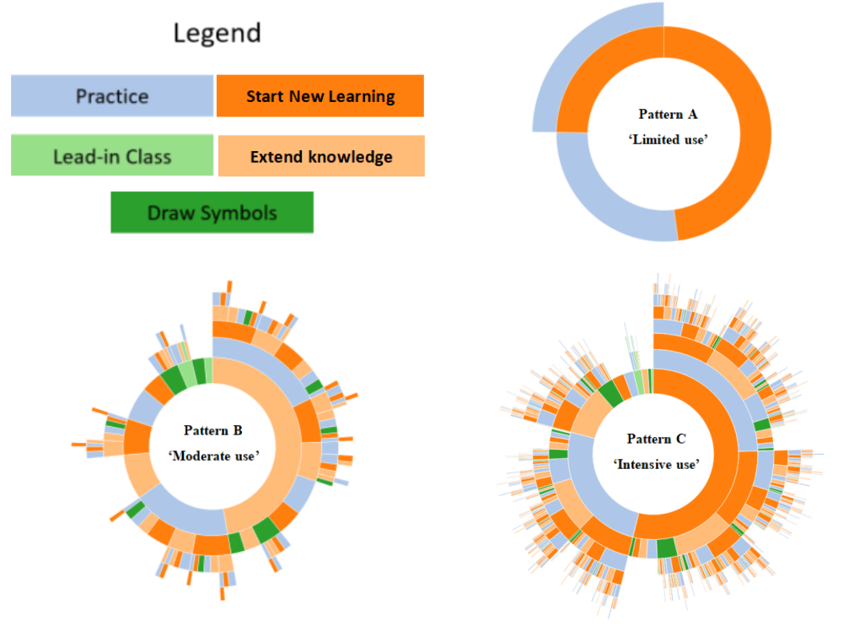
Figure 1. Using patterns
We divided teachers’ usage patterns into three groups according to the times they perform action on the E-textbook. For the top 27%, we call their usage patterns ‘Intensive use’; For those between 27% to 72%, we call their patterns ‘Moderate use’; And the other teachers’ usage patterns are ‘Limited use’, they operated less than 8 times.
Pattern A is ‘Limited use’, we discovered that they only have three different frequent sequences, which are {N}, {P}, {N, P}. As shown in figure 1, this using pattern is very simple. Typically, when start a new lesson, teachers would perform the action ‘Start New-learning’ and they might end the lesson with action ‘Practice’. They probably didn’t use the E-textbook during other periods of the class, so we assume that they were not using the E-textbook frequently and effectively to bring better learning experience to the learners.
Pattern B is ‘Moderate use’, teachers with this using pattern operated all five actions on the E-textbook as they tried to explore all the different functions of the E-textbook, so it has many frequent sequences with different combinations in different lengths, which makes pattern B more complex than pattern A. As shown in the Figure 1, pattern B has some mid-length frequent sequences like {N, E, N, P}, the longest frequent sequence of pattern B is {N, P, E, N, P, E}, a 6-length sequence with a support of 53. With these frequent sequences, we assume that teachers with pattern B were making effort to discover a better way to use the E-textbook in their teaching and create better learning experience for the learners. For example, the frequent sequence {N, P, E, N, P, E} shows that teachers with pattern B tried to start more than one action ‘Start New-learning’ in a class, they started new learning for twice in a class, and after each learning they would assign some practices for the learners to consolidate knowledge. Also, after each practice, teachers would perform action ‘Extend knowledge’ to provide learners more knowledge which is related to the new learning and the practices to help learners understand the lesson better after they finish the practice.
Pattern C is the ‘Intensive use’, a very complex and diverse using pattern. Some of the frequent sequences can be very long like {N, L, N, D, E, N, P, E}, an 8-length sequence. After started a new learning at the beginning of the class, teachers were trying to use attractive methods or materials to lead-in the learning in a much more interesting way. With the action ‘Lead-in class’, a class could be more interesting, learners probably felt excited about the learning and had a better learning experience, action L is quite important at the beginning of a vivid class. After finished the first learning period of this class, teachers started another new learning period with another action ‘Start New-learning’, then they performed action ‘Draw symbols’ to draw symbols or leave some comments to remind the learners to prepare for learning more extensive knowledge which was showed to learners with action ‘Extend knowledge’. Teachers even started the third new learning in this class, after the first two learning, teachers skillfully performed action ‘Practice’ to consolidate the knowledge the learners had in the class. Finally, teachers performed action ‘Extend knowledge’ to offer learners chances to discover more by themselves and make decisions about what was the most they want to learn about this class. With a total of 549 sequences and half of them are 4-length sequences or even longer sequences, and many of these frequent sequences had supports larger than 100, we can assume that teachers with pattern C tried to perform different actions to seek a better way to use the E-textbook in class. In conclusion, teachers with pattern C tried so many complex combinations to improve their teaching and E-textbook using skills, they are very intensive to use the E-textbook in different ways to help them to teach more effectively and bring better learning experience to learners of their class.

- Discussion

This study introduced a real-world situation of some teachers’ E-textbook usage patterns. We discovered three different usage patterns and assumed that different patterns might represent different efficiency of using the E-textbook in class. Typically, we assume that teachers with pattern which is more complex can probably bring more resources to the learners in the class to make their lesson more attractive and effective. And with some more rational combinations of actions in their teaching with E-textbook might make the whole process of their teaching more reasonable with higher efficiency. Our future work will be oriented to discover how these different kinds of ICT patterns would affect teachers’ outcome. We want to be able to provide more advises for teachers to improve their teaching efficiency with better ICT patterns.

5. Reference

Martinovic, D., & Zhang, Z. (2012). Situating ICT in the teacher education program: Overcoming challenges, fulfilling expectations. Teaching and Teacher Education, 28(3), 461-469.
Wang, J., Han, J., & Li, C. (2007). Frequent closed sequence mining without candidate maintenance. IEEE Transactions on Knowledge and Data Engineering, 19(8)

